

SAMCO AL-WATANIYA FOR CONSTRUCTION

Consolidated
Contractor's Claim
For Extension of Time and Additional Payment
Construction Works of the Civil Works for
Buildings B1, B2, B3 and B4 at The Big Project

Contract Reference: Roya-Big-2025-01
Between: Samco Al-Wataniya (Contractor) and Roya for Real Estate Investment (Employer)
Cut-off Date: 5th May 2026

Contents
1. Preamble 4
1.1 Purpose of the Submission 4
1.2 Contractual Framework 4
1.3 Scope of the Project 5
1.4 Contract Data 6
1.5 Priority of Contract Documents 6
1.6 Without Prejudice and Reservation of Rights 7
2. Claim No. (01): Delayed Supply of Free-Issue Steel Reinforcement by the Employer 8
2.1 Executive Summary 8
2.2 Contractual Basis 8
2.3 Factual Background 9
2.4 Entitlement 10
2.5 Steel Analysis Data 10
Table 1: Master Activity Steel Analysis 10
Table 2: Employer Steel Supply at Site 11
Table 3: P6 Activity Export 12
Table 4: Activity Relationships 152
Table 5: Fragment Network 192
3. Claim No. (02): Change in Issued for Construction (IFC) Drawing Packages 193
3.1 Executive Summary 193
3.2 Contractual Basis 193
3.3 Factual Background 193
3.4 Entitlement 194
3.5 IFC Analysis Data 195
Table 1: Master Activity Steel Analysis 195
4. Claim No. (03): Water Leakage in Project Site 197
4.1 Executive Summary 197
4.2 Contractual Basis 197
4.3 Factual Background 198
4.4 Entitlement 199
4.5 Delay Analysis 199
5. Claim No. (04): Engineer's Delayed Reply to the Contractor's Documents 200
5.1 Executive Summary 200
5.2 Contractual Basis 200
5.3 Factual Background 200
5.4 Entitlement 202
5.5 Delay Analysis 202
6.Consolidated Summary of Entitlements 203
7.Caveat 204

Preamble

Purpose of the Submission
1. Samco Al-Wataniya for Construction (hereinafter the "Contractor") hereby submits this Consolidated Contractor's Claim to the Engineer in accordance with Sub-Clause 20.1 [Contractor's Claims] of the Conditions of Contract. This submission sets out the Contractor's entitlement to an Extension of Time for Completion arising from four distinct events and circumstances that have materially impacted the progress and cost of the Works.
2. This consolidated submission comprises the following 4 separate claims:
• Claim 1: Delayed Supply of Free-Issue Steel Reinforcement by the Employer
• Claim 2: Changes in Issued for Construction (IFC) Drawing Packages
• Claim 3: Water Leakage in Project Site
• Claim 4: Engineer's Delayed Reply to the Contractor's Documents
3. During the course of the Works, the Contractor has encountered a series of events and circumstances arising from actions and omissions attributable to the Employer and/or the Engineer, and from events beyond the Contractor's control, which have materially impacted the progress, cost, and Time for Completion of the Works. Pursuant to the applicable provisions of the Conditions of Contract, the Contractor hereby formally submits this Consolidated Contractor's Claim setting out its entitlements to an Extension of Time for Completion and associated additional payment.
4. The Contractor's entitlement to an extension of Time for Completion gives rise to a corresponding entitlement to prolongation costs. Given the ongoing nature of several delay events and the requirement to complete the delay analysis, prolongation costs will be quantified in full in a separate dedicated submission to be served on the Engineer in due course.
5. By virtue of this submission, and to the cut-off date of 05 May 2026, the Contractor claims an extension of the Time for Completion for 126 days, modifying the completion date of the Project to be on 15-Sep-2027, as derived from the delay analysis prepared by the Contractor and attached to the submission.

1.2 Contractual Framework
1. This submission arises out of Contract Reference Roya-Big-2025-01 (the "Contract") between Roya for Real Estate Investment (the "Employer") and Samco Al-Wataniya for Construction (the "Contractor") for the Construction Works of the Civil Works for Buildings B1, B2, B3 and B4 at The Big Project.
2. The Contract was made effective on 30 April 2025. According to Sub-Clause 8.1 [Commencement of Works] of the Particular Conditions of Contract, the Commencement Date is the latest of the following:
• Letter of Acceptance
• Site Handover
• Receipt of undertaking letter that the Employer is responsible for all permits
• Receipt of the advance payment
3. Pursuant to the letter received from the Employer on 11 September 2025, it was confirmed that the Commencement Date for the Project is 11 September 2025, being the date on which all the requirements under Sub-Clause 8.1 were satisfied.
4. The Works are required to be completed within 19 months from the Commencement Date, subject to such Extensions of Time as may be granted under the Contract. Therefore, the original completion date was set to be 11 April 2027.

1.3 Scope of the Project
1. The Big Project is a development comprising four (4) buildings designated Buildings B1, B2, B3 and B4. Under Contract Reference Roya-Big-2025-01, the Contractor is engaged by the Employer to carry out the Engineering, Procurement and Construction of the Civil Works for all four buildings on a fixed-price, lump-sum basis in accordance with the Contract and the Conditions of Contract.
2. The Works are designed by the Employer and are executed in accordance with the IFC drawing packages and specifications issued by or on behalf of the Employer through the Engineer. The Conditions of Contract adopted are the FIDIC Conditions of Contract for Building and Engineering Works Designed by the Employer, First Edition 1999 (the "Red Book"), as modified by the Particular Conditions.

1.4 Contract Data
The key data and particulars of the Contract are set out in the table below, as derived from the Contract Agreement, Appendix to Tender, and associated contract documents:
Contract Title | Construction Works of the Civil Works for Buildings B1, B2, B3 and B4 at The Big Project
Contract Reference | Roya-Big-2025-01
Conditions of Contract | FIDIC Red Book 1999, as amended by Particular Conditions
Commencement Date | 11 September 2025
Time for Completion | 19 Months from Commencement Date
Original Completion Date | 11 April 2027
Employer | Roya for Real Estate Investment
Contractor | Samco Al-Wataniya for Construction
Engineer | ACE Project Management - Moharram Bakhoum
Accepted Contract Amount | EGP 367,286,025
Advance Payment | 25% of Contract Amount (30% Cash / 70% Free-Issue Steel)
Delay Damages | 1% per week of outstanding Works value
Maximum Delay Damages | 10% of Contract Price
Governing Law | Laws of Arab Republic of Egypt

1.5 Priority of Contract Documents
In the event of ambiguity or discrepancy between any documents forming part of the Contract, precedence shall be determined in accordance with Sub-Clause 1.5 [Priority of Documents]:
1. The Agreement
2. The Appendix to Tender
3. The Particular Conditions
4. The General Conditions
5. General Requirements
6. The Bill of Quantities
7. Drawings
8. Soil Report
9. Site Layout

1.6 Without Prejudice and Reservation of Rights
1. This submission is made without prejudice to any of the Contractor's other rights or remedies under the Contract or at law. The entitlement figures presented herein represent the Contractor's best assessment as at the cut-off date of 05 May 2026. The Contractor expressly reserves the right to supplement, amend, and update this submission as further information becomes available, including the results of the ongoing delay analyses and the quantification of prolongation costs associated with each head of claim.
2. The Contractor's entitlement to an extension of Time for Completion gives rise to a corresponding entitlement to prolongation costs. Given the ongoing nature of several delay events and the requirement to complete the delay analysis, prolongation costs will be quantified in full in a separate dedicated submission to be served on the Engineer in due course.
3. Nothing contained in this submission shall be construed as a waiver of any right or remedy available to the Contractor under the Contract or applicable law, and all rights are expressly reserved.

Event No. (01): Delayed Supply of Free-Issue Steel Reinforcement by the Employer

2.1 Executive Summary
In accordance with Sub-Clause 14.2 of the Appendix to Tender, it is the Employer's responsibility to supply the required steel reinforcement as part of the Advance payment. However, the Employer significantly delayed the supply of the required steel reinforcement, which has significantly delayed the Works. Notwithstanding the Contractor's mitigation measures to progressively secure approximately 565 tons of steel reinforcement, substantial disruption to construction activities has occurred as a direct result of the inconsistent and delayed supply by the Employer.

2.2 Contractual Basis
Sub-Clause 4.20 [Employer's Equipment and Free-Issue Material] of the Particular Conditions states:
"The Contractor shall promptly give notice to the Engineer of any shortage, defect or default in these Materials. The Contractor shall submit to the Engineer, for approval, a 1-month prior look-ahead schedule for the required free-issue Materials."
Sub-Clause 14.2 [Advance Payment] provides that:
"25% of the Accepted Contract Amount to be paid as follows: 30% Cash against Bank Check; 70% Steel supplied by Employer according to the approved Programme."
Sub-Clause 8.4(e) [Extension of Time for Completion] and Sub-Clause 20.1 [Contractor's Claims] entitle the Contractor to an Extension of Time together with associated Costs.
In light of the above, and since the Employer’s supply of steel has been significantly delayed, with the third batch of steel reinforcement still not delivered as of the date of this submission, the Contractor’s progress has been materially affected.
Accordingly, the Contractor is entitled to an Extension of Time for Completion together with the associated Costs pursuant to Sub-Clause 8.4(e) [Extension of Time for Completion] and Sub-Clause 20.1 [Contractor’s Claims] of the Conditions of Contract.

2.3 Factual Background
The following chronological sequence documents the Employer's delayed supply of steel reinforcement:
1. 27 September 2025 —Contractor submitted the required quantities of reinforcement steel for the first batch.
2. 30 September 2025 — Contractor reduced the quantity of the first batch due to changes in the Site conditions to allow to ensure smooth progress of the excavation and replacement soil works.
3. 26 November 2025 — Contractor submitted the required quantities of reinforcement steel for the second batch with a total of 726 tons.
4. 9 December 2025 — Employer supplied 440.2 Ton of the first batch required quantity.
5. 6 January 2026 — Contractor submitted the required quantities of reinforcement steel for the third batch.
6. 15 January 2026 — Contractor submitted a notice of claim regarding the delay in supplying the second batch and highlighted that such delay shall delay the progress of the Works. Also, the Contractor informed the Engineer that, as a gesture of goodwill, it has supplied 120 tons of the required quantity to prevent the suspension of the Works.
7. 26 January 2026 — Contractor submitted a further notice of claim regarding the delay of the second batch to inform the Engineer of the continuous delay to supply the quantity of the second batch and to notify the Engineer that all the available steel, whether supplied by the Employer or the Contractor, have already been incorporated in the Works, and accordingly the Works shall be suspended.
8. 7 February 2026 — Contractor submitted a further notice of claim to notify the Engineer of the delay to receive the second and third batches of reinforcement steel and that the Contractor shall not be held liable for any suspension of the Works accordingly.
9. 16 February 2026 —Engineer provided that the steel reinforcement required for the relevant Works has already been delivered and that the Contractor already tried to mitigate the delay by supplying an amount of the required steel reinforcement.
10. 24 February 2026 — Contractor clarified that the quantities supplied by the Employer till the date of the Contractor’s letter are not compatible with the Site requirements and the quantities requested by the Contractor. Moreover, the Contractor asserted that the Contractor’s efforts and mitigation measures to supply some of the required steel reinforcement quantity, shall not be considered a waiver by the Contractors of its rights and accordingly, the Contractor shall not be held responsible for the occurring disruption and the delays resulting from the irregular supply of steel by the Employer.
11. 31 March 2026 — Contractor notified the Engineer that, till the date of its letter, merely half of the second batch has been delivered, and none of the third batch has been delivered. Also, the Contractor notified the Engineer that the available reinforcement steel at Site is insufficient to complete the planned Works
12. 19 April 2026 — Contractor reiterated concerns and urged expedited steel supply to prevent any further delays.

2.4 Entitlement
Notwithstanding the Contractor’s mitigation measures and its efforts to progressively secure and make available approximately 565 tons of steel reinforcement to minimize the impact on the Works, such measures do not negate the fact that substantial disruption to the construction activities has occurred as a direct result of the inconsistent and delayed supply of steel reinforcement by the Employer, which remains the Employer’s responsibility under the Contract. The Contractor exerted all possible efforts to maintain progress and ensure continuity of the Works, and any temporary procurement or arrangement of steel quantities by the Contractor was undertaken solely for the benefit of the Project and as a gesture of good faith, without prejudice to its contractual entitlements.
Following the delay analysis performed, the Employer's delayed and inconsistent supply of steel reinforcement was found to have impacted the critical path and resulted in a delay to completion equal to 117 days.
In accordance with the SCL Delay and Disruption Protocol, Guidance to Core Principle 4, paragraph 4.6:
"The goal of the EOT procedure is the ascertainment of the appropriate contractual entitlement to an EOT; the analysis should not start from a position of considering whether the Contractor needs an EOT in order not to be liable for liquidated damages."
The Contractor is fully entitled to an Extension of Time together with all associated prolongation costs.

2.5 Steel Analysis Data

CRITICAL NOTICE AND CORRESPONDENCE REGISTER
Date | Ref. | Event | Subject | Purpose | Relevant Provision
25-Sep-2025 | STR-010 | EV01 | Supply of reinforcement steel for the project | Initial steel supply request / programme dependency | Appendix Item 20 / SC 14.2; SC 4.20
29-Sep-2025 | STR-011 | EV01 | Request to reduce first reinforcement steel delivery | Adjusted first delivery request due to site constraints | Appendix Item 20 / SC 14.2; SC 4.20
26-Nov-2025 | STR-025 | EV01 | Supply of reinforcement steel - second delivery | Batch 02 request and supply dependency | Appendix Item 20 / SC 14.2; SC 4.20
06-Jan-2026 | STR-042 | EV01 | Supply of reinforcement steel - third delivery | Batch 03 request | Appendix Item 20 / SC 14.2; SC 4.20
15-Jan-2026 | STR-044 | EV01 | Delay in supplying reinforcement steel | Delay notification and reservation of time / cost rights | SC 4.20; SC 8.4; SC 20.1
26-Jan-2026 | STR-048 | EV01 | Follow-up on delay of reinforcement steel delivery | Warning of stock depletion and continuing impact | SC 4.20; SC 8.4; SC 20.1
07-Feb-2026 | STR-051 | EV01 | Reinforcement steel supply status and EOT entitlement | Notice of depletion / non-delivery and EOT position | SC 4.20; SC 8.4; SC 20.1
24-Feb-2026 | STR-053 | EV01 | Reinforcement steel Order No. 2 delay | Late / irregular supply and commercial position | SC 4.20; SC 8.4; SC 20.1
31-Mar-2026 | STR-062 | EV01 | Follow-up on reinforcement steel delivery | Partial delivery and outstanding supply | SC 4.20; Appendix Item 20 / SC 14.2; SC 8.4; SC 20.1
19-Apr-2026 | STR-069 | EV01 | Follow-up on steel supply and cumulative project impact | Cumulative delay, mitigation and reservation | SC 4.20; SC 8.4; SC 20.1
27-Apr-2026 | STR-071 | EV01/EV02 | Early warning and notification of fact | Consolidated notice of steel and design constraints | SC 1.9; SC 4.20; SC 8.4; SC 20.1

Cause & Effect Analysis
CONTRACTUAL CAUSE  Employer-supplied steel required in accordance with the approved Program and Contractor requisitions. | FACTUAL EVENT  Late, partial and sequenced deliveries against the required batches. | OPERATIONAL EFFECT  Insufficient steel availability for identified reinforcement-fixing activities. | SCHEDULE EFFECT  Delay transferred through linked structural logic to milestones and Project Finish where critical.

The steel correspondence and delivery records indicate that Batch 02 was required by 27-Nov-2025 in the amount of 726 tons. The current delivery summary records 371.115 tons delivered on 14-Feb-2026 and 355.840 tons delivered on 05-May-2026. The native EV01 Batch 02 fragnet models the partial-delivery milestone on 15-Feb-2026 and the complete-delivery milestone on 05-May-2026.
The affected work packages include reinforced-concrete raft / footing, walls, columns, cores, slabs, beams, stairs, ramps and water-tank reinforcement activities. The detailed activity IDs and names are listed in Annex B and the native P6 comparison. The Contractor's mitigation, including self-procurement and resequencing where recorded, must be credited in the assessment and does not relieve the Employer of the consequences of any proven late free-issue supply.

Table 1: Master Steel Analysis

# | Subject | Dates | Total (Ton)
Batch01 | BL Date | 3-Nov-25 | 586.98
 | Delivery of Patch01 - Part01 | 27-Oct-25 | 146.8
 | Delivery of Patch01 - Part02 | 9-Dec-25 | 440.18
Batch02 | BL Date | 27-Nov-25 | 726.96
 | Delivery of Patch02 - Part01 | 14-Feb-26 | 371.12
 | Delivery of Patch02 - Part02 | 5-May-26 | 355.84
Batch03 | BL Date | 13-Jan-26 | 524
 | Delivery of Patch03 | Continuing Delay Event | 0
Total |  |  | 1837.9

Table 2: Employer Steel Supply at Site
.The following table documents the actual steel deliveries made by the Employer to date:
SR | Coding No. | Ref | Supplier | Unit/Bundle | Total Quantity | Date of delivery | Submitted date | Received Date
1 | SAMCO-PCO-MIR-STR-015-R00 | 15 | Roya | TON | 146.8 | 28-Oct-25 | 29-Oct-25 | 29-Oct-25
2 | SAMCO-PCO-MIR-STR-050-R00 | 50 | Roya | TON | 440.18 | 9-Dec-25 | 9-Dec-25 | 09-Dec-25
3 | SAMCO-PCO-MIR-STR-067-R00 | 67 | Roya | TON | 52.71 | 12-Feb-26 | 14-Feb-26 | 16-Feb-26
4 | SAMCO-PCO-MIR-STR-068-R00 | 68 | Roya | TON | 181.73 | 13-Feb-26 | 14-Feb-26 | 16-Feb-26
5 | SAMCO-PCO-MIR-STR-069-R00 | 69 | Roya | TON | 60.425 | 13-Feb-26 | 14-Feb-26 | 16-Feb-26
6 | SAMCO-PCO-MIR-STR-070-R00 | 70 | Roya | TON | 76.25 | 14-Feb-26 | 15-Feb-26 | 16-Feb-26
7 | SAMCO-PCO-MIR-STR-080-R00 | 80 | Roya | TON | 355.84 | 4-May-26 | 5-May-26 | 06-May-26

2

Activity Relationships & Fragnets Network

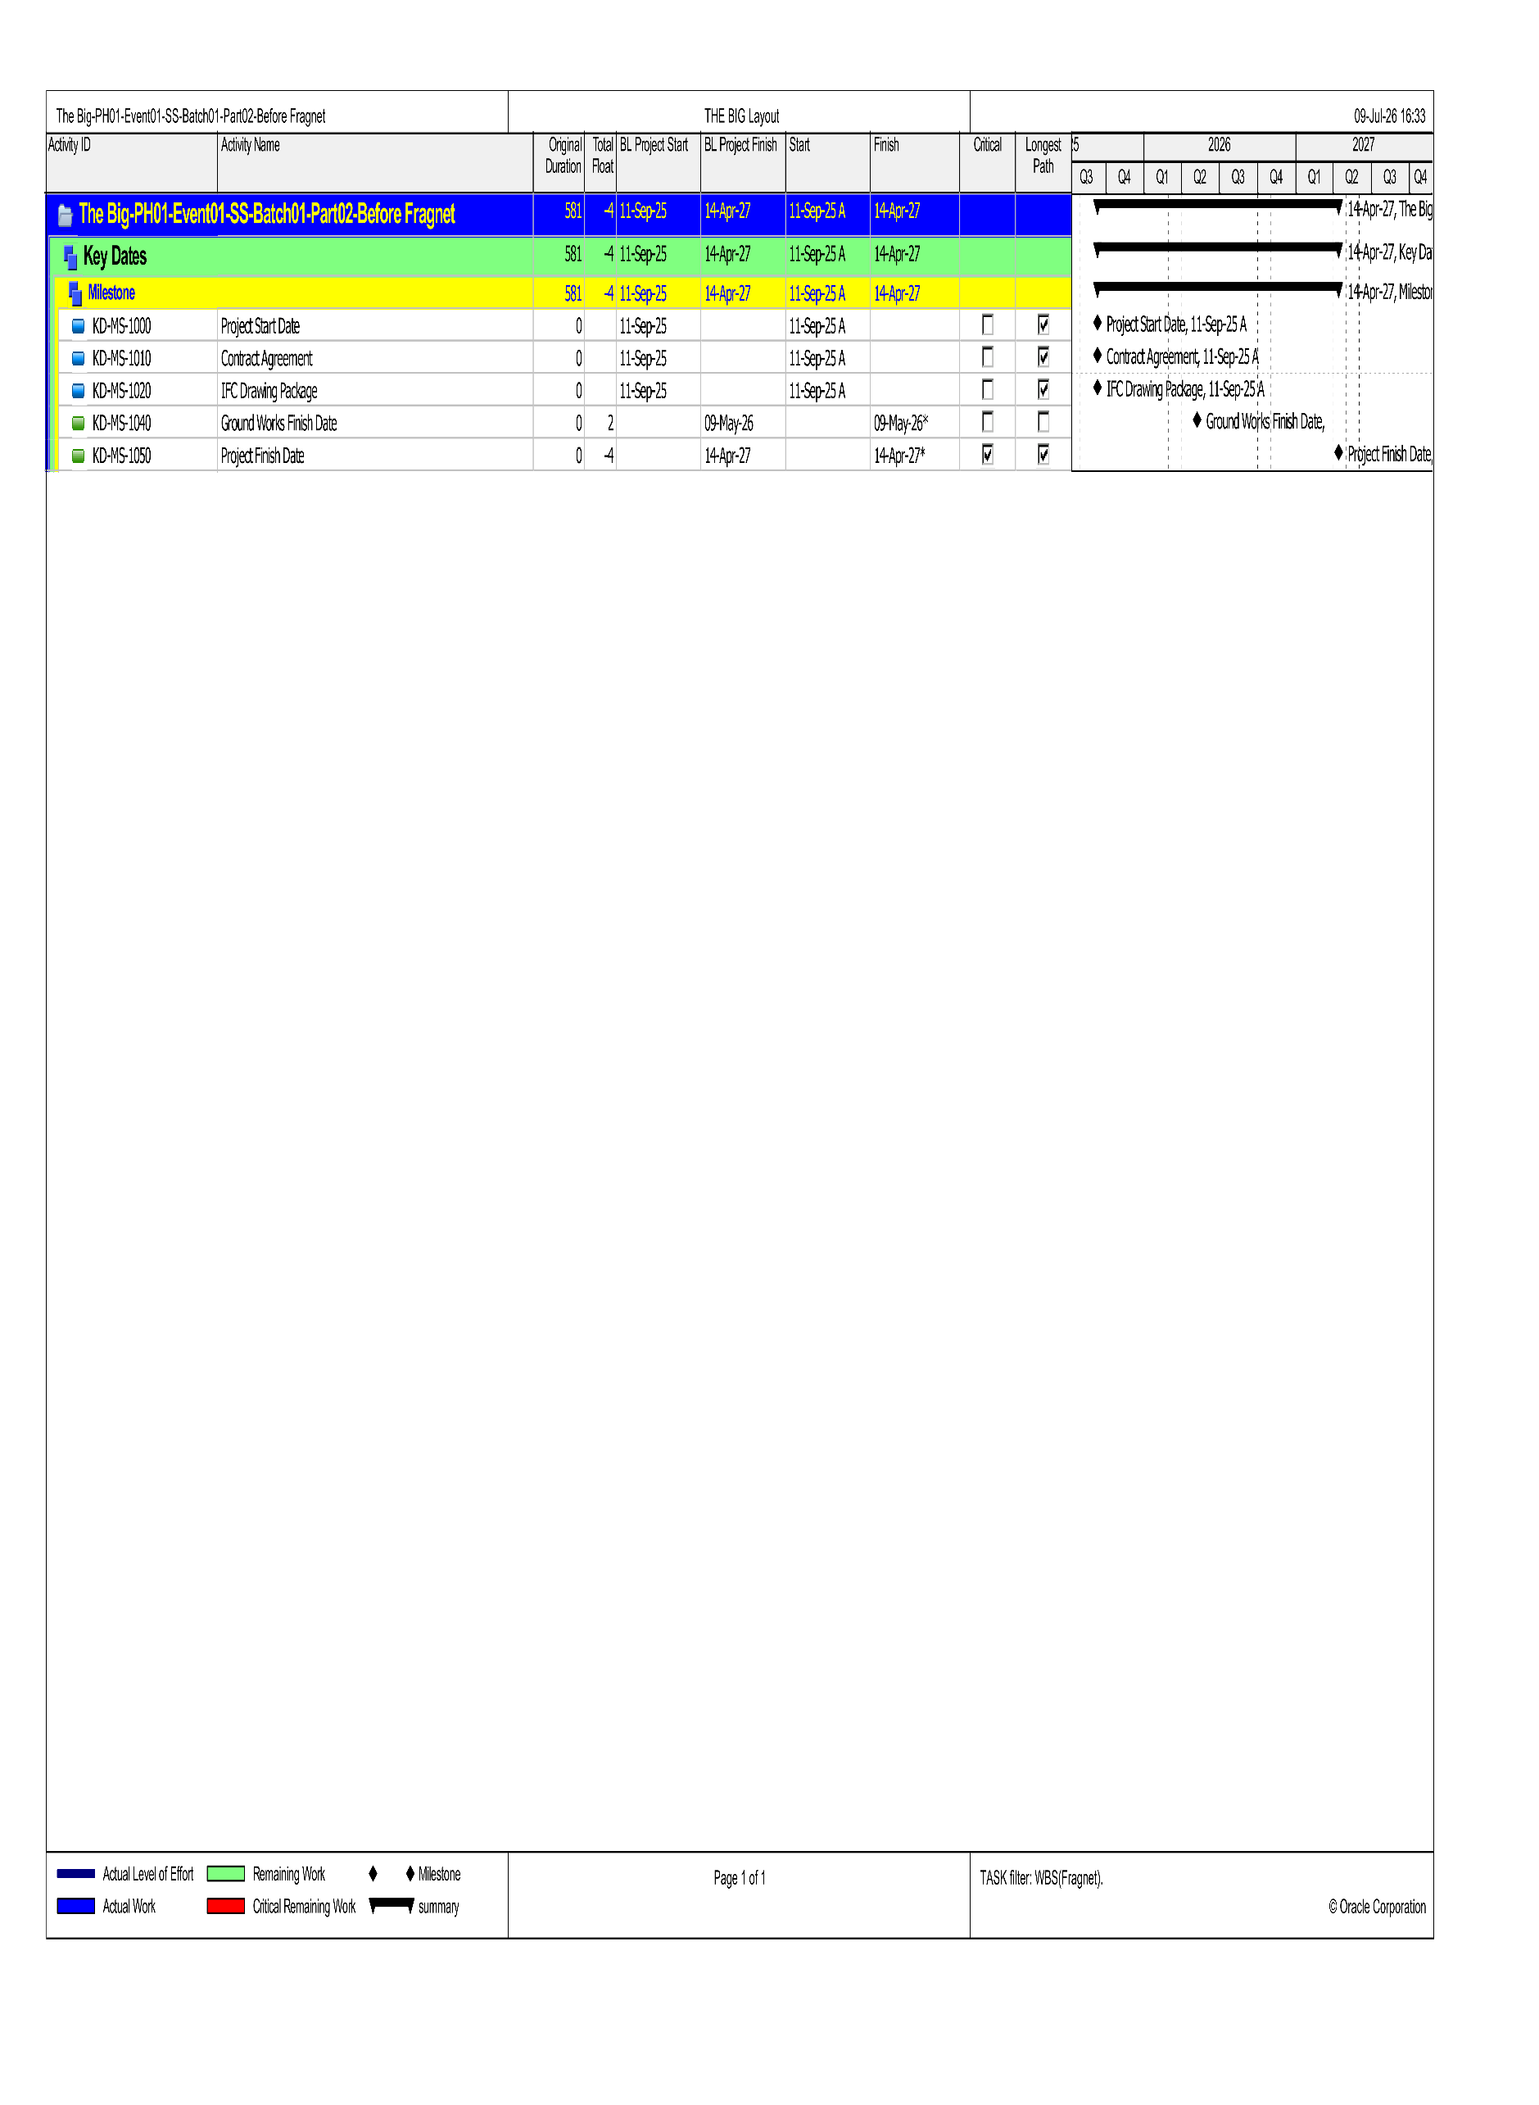

`(Batch01-Before Fragnet Activities)
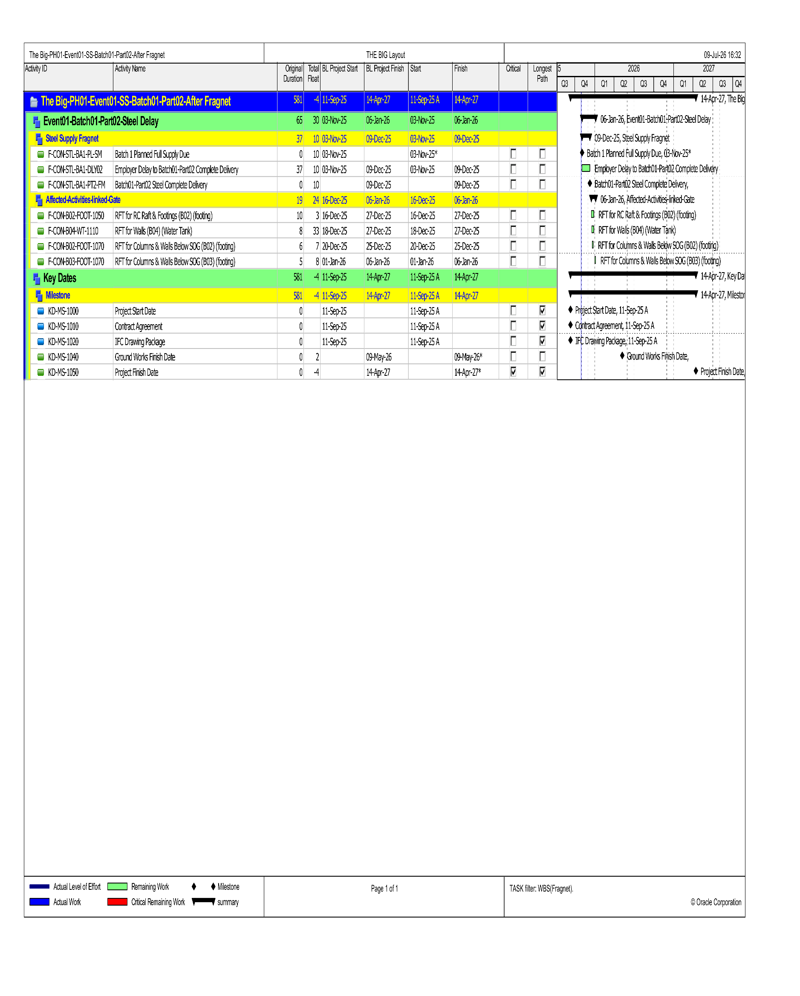

(Batch01-After Fragnet Activities)

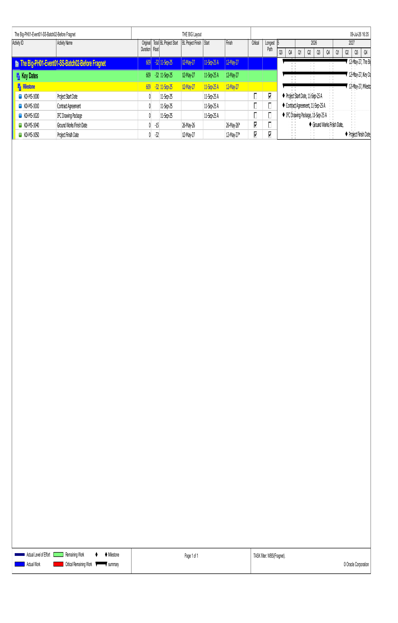

(Batch02-Before Fragnet Activities)
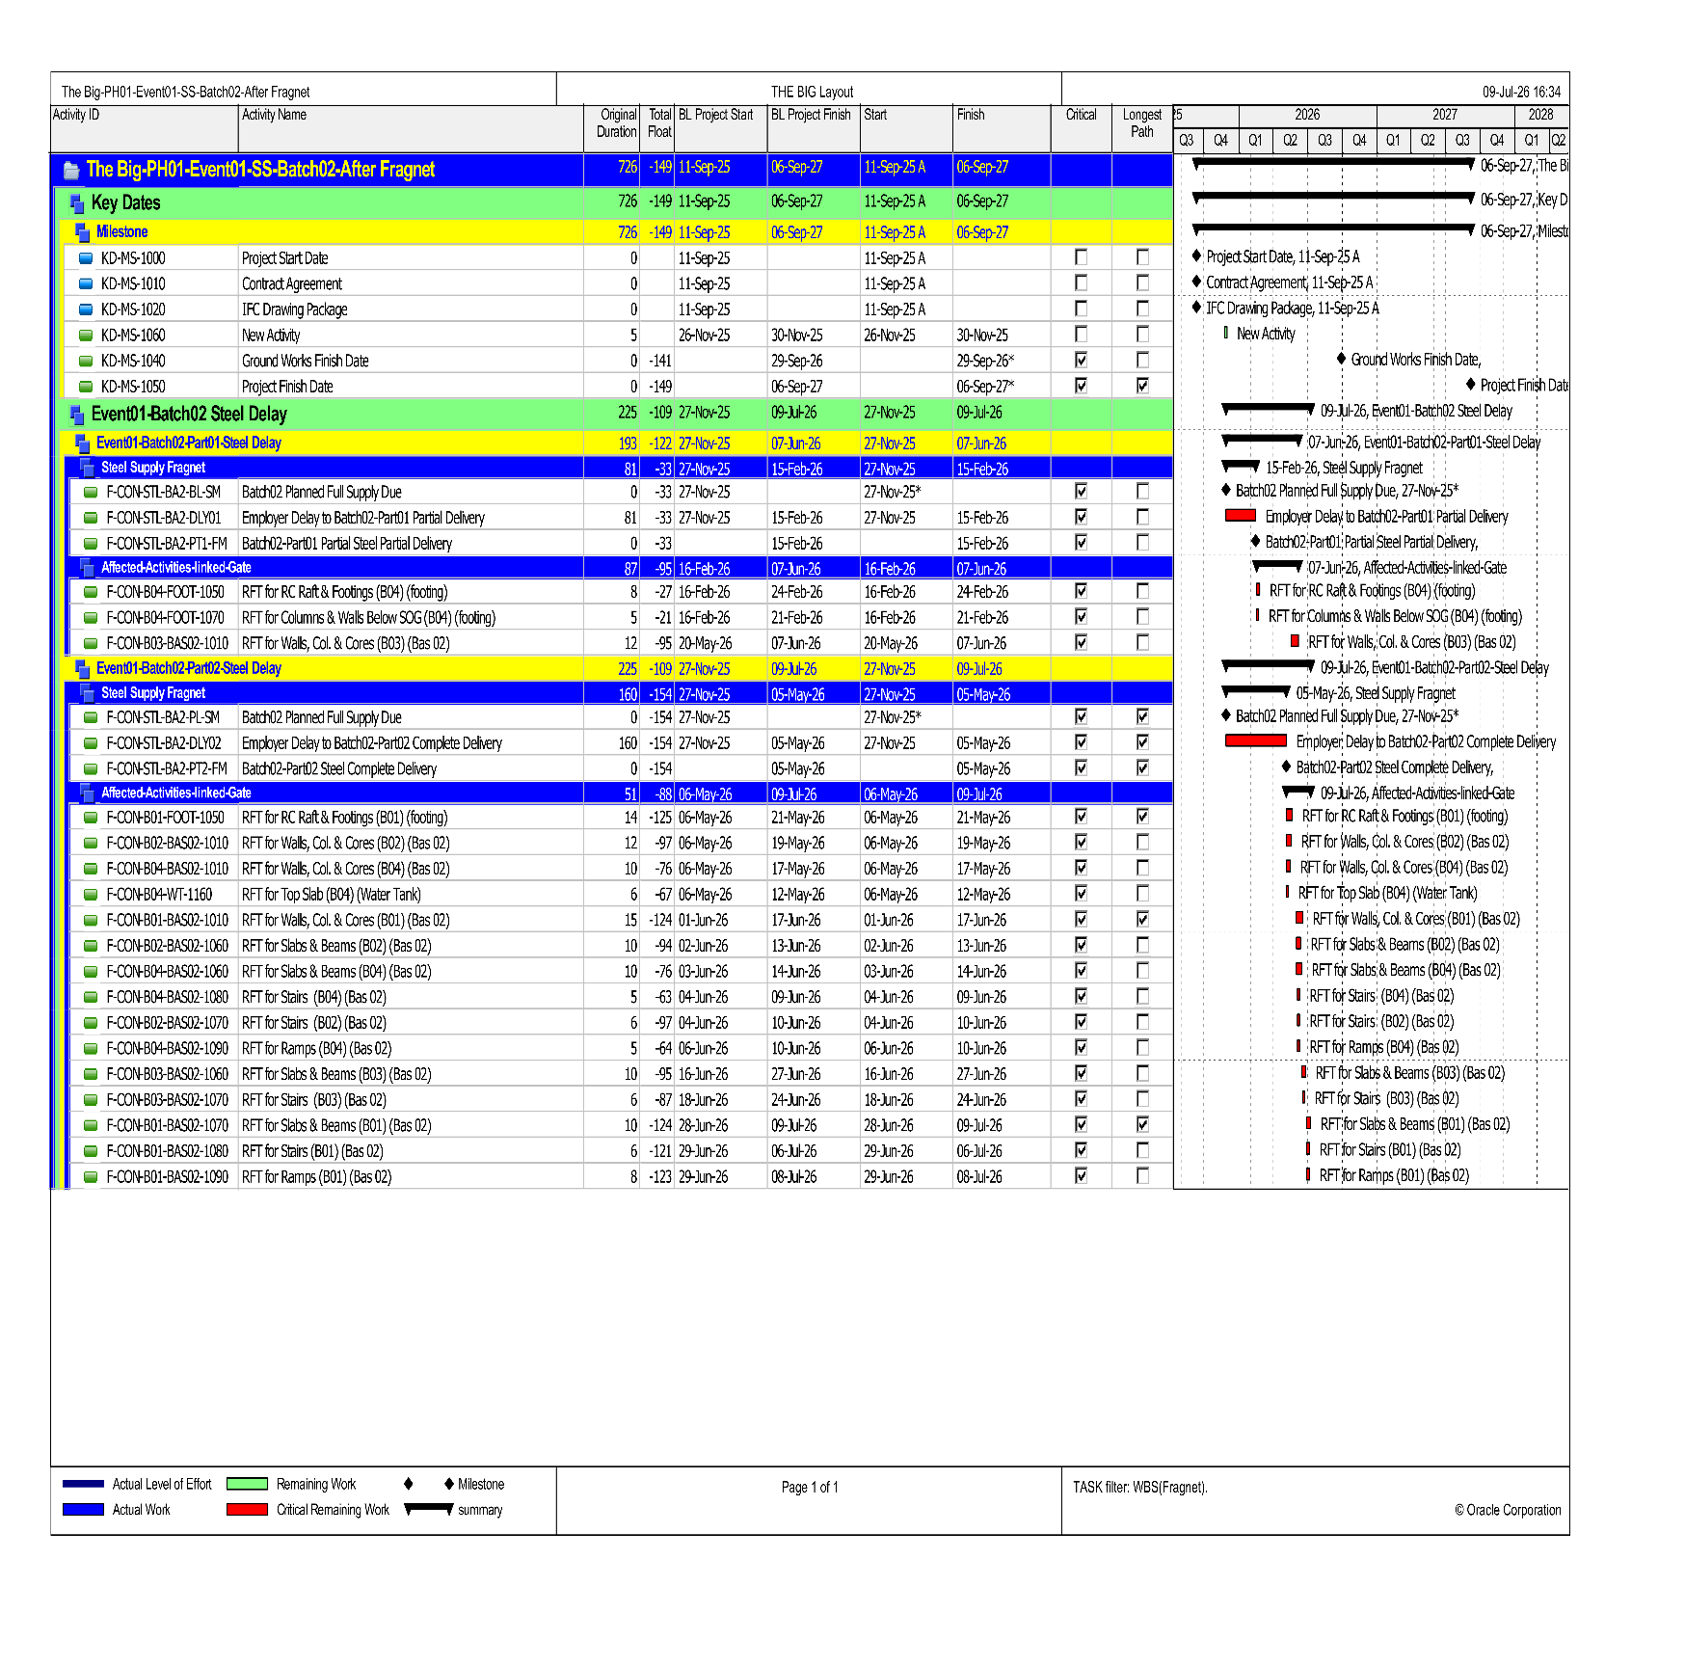
`

(Batch02-After Fragnet Activities)
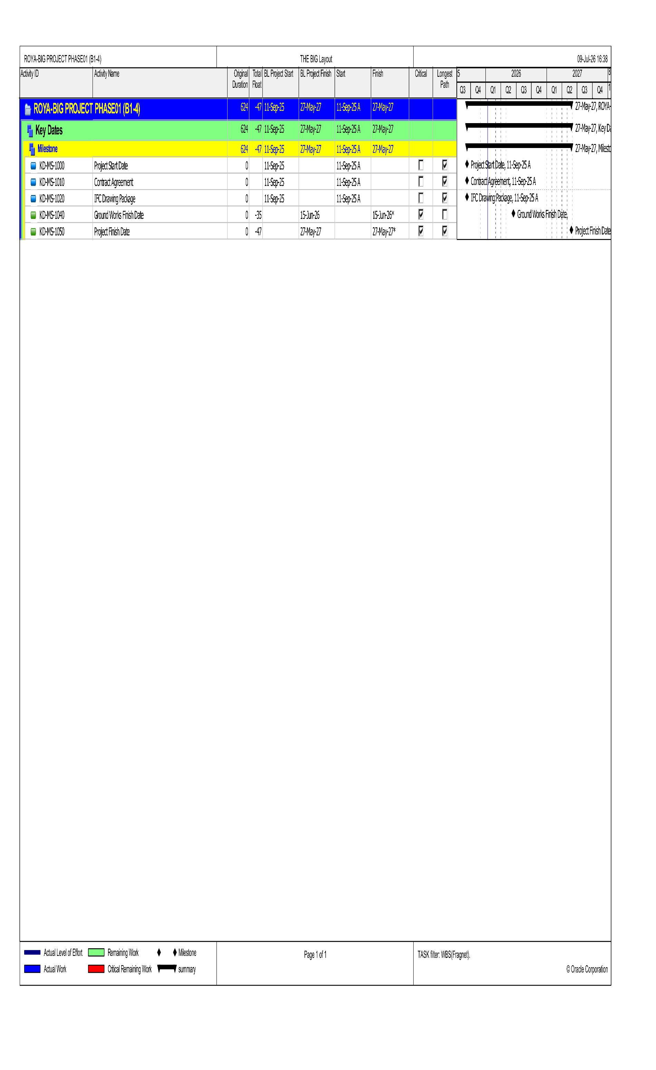

(Batch03-Before Fragnet Activities)
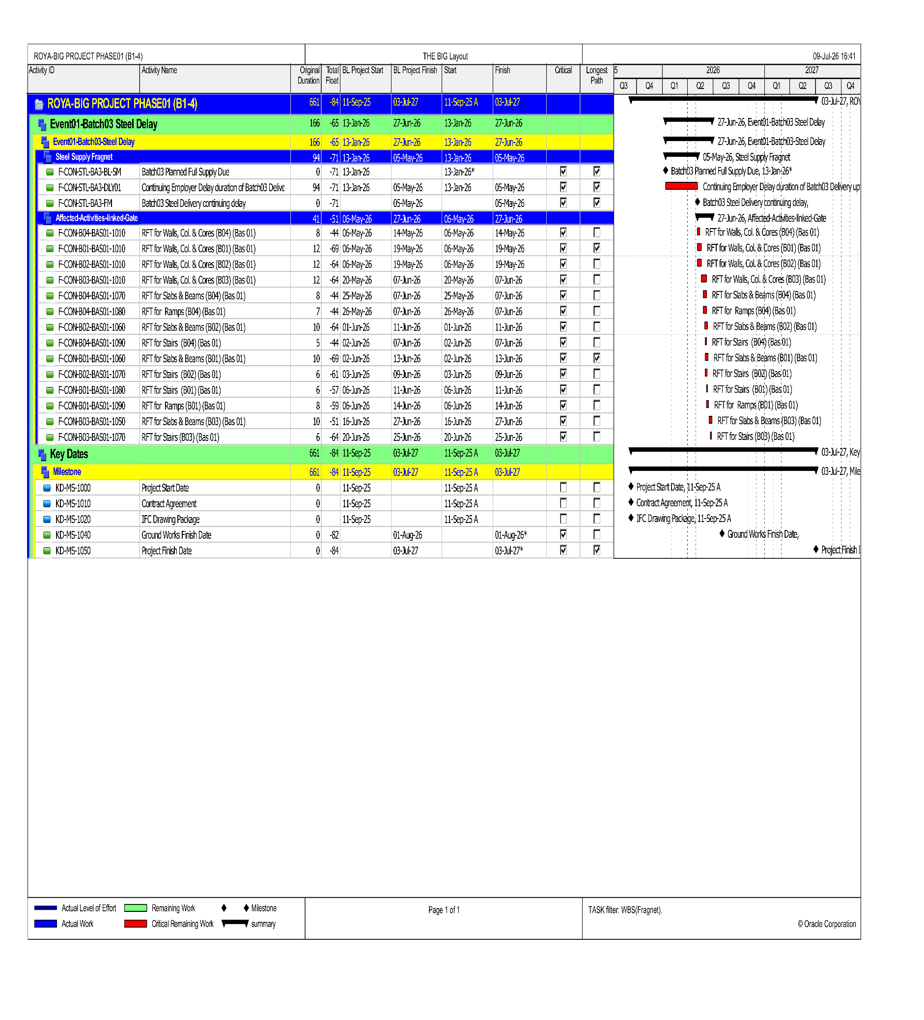

(Batch03-After Fragnet Activities)

Contractual milestones and completion assessment
Delay Event | Data Date | Activity ID | Milestone / Activity Name | BEFORE FRAGNET |  | AFTER FRAGNET |  | Float Change  (Days) | Finish Movement
 |  |  |  | Total Float | Forecast Finish | Total Float | Forecast Finish
EV01 –Batch01 | 31-Oct-25 | KD-MS-1040 | Ground Works Finish Date | 2 | 9-May-26 | 2 | 9-May-26 | 0 | 0
EV01 –Batch01 | 31-Oct-25 | KD-MS-1050 | Project Finish Date | -4 | 14-Apr-27 | -4 | 14-Apr-27 | 0 | 0
EV01 –Batch02 | 26-Nov-25 | KD-MS-1040 | Ground Works Finish Date | -15 | 26-May-26 | -141 | 29-Sep-26 | -126 | 126
EV01 –Batch02 | 26-Nov-25 | KD-MS-1050 | Project Finish Date | -32 | 12-May-27 | -149 | 6-Sep-27 | -117 | 117
EV01 –Batch03 | 13-Jan-26 | KD-MS-1040 | Ground Works Finish Date | -35 | 15-Jun-26 | -82 | 1-Aug-26 | -47 | 47
EV01 –Batch03 | 13-Jan-26 | KD-MS-1050 | Project Finish Date | -47 | 27-May-27 | -84 | 3-Jul-27 | -37 | 37

Event No. (02): Change in Issued for Construction (IFC) Drawing Packages

3.1 Executive Summary
The Engineer issued numerous IFC drawing packages at various stages of the Project, which created confusion to the Contractor. The last package issued on 18 March 2026 was significantly different from the previous version, leading to suspension of Project Works.

3.2 Contractual Basis
Sub-Clause 1.9 [Delayed Drawings or Instructions] states:
"The Contractor shall give notice to the Engineer whenever the Works are likely to be delayed or disrupted if any necessary drawing or instruction is not issued to the Contractor within a particular time...."
Sub-Clause 8.4 [Extension of Time for Completion] of the Conditions of the Contract, which states that:
“The Contractor shall be entitled, subject to Sub-Clause 20.1 [Contractor’s Claims], to an extension of the Time for Completion if and to the extent that completion for the purposes of Sub-Clause 10.1 [Taking Over of the Works and Sections] is or will be delayed by any of the following causes: a cause of delay giving an entitlement to extension of time under a Sub-Clause of these Conditions.”
Sub-Clause 20.1 [Contractor's Claims] of the Conditions of the Contract, which stipulates that:
If the Contractor considers himself to be entitled to any extension of the Time for Completion and/or any additional payment, under any Clause of these Conditions or otherwise in connection with the Contract, the Contractor shall give notice to the Engineer, describing the event or circumstance giving rise to the claim. The notice shall be given as soon as 11 practicable, and not later than 28 days after the Contractor became aware, or should have become aware, of the event or circumstance.

3.3 Factual Background
1. At the outset, the Contractor from the Commencement Date is working on the IFC package submitted on the 4th of August 2025¹³, which is different from the IFT drawing. However, it had not stopped the Contractor from performing his obligations.
2. 27 October 2025¹⁴ — Engineer issued an updated IFC drawing package, which contains the same structural drawings in addition to the architectural and electromechanical drawings.
3. 18 March 2026¹⁵ — and after 6 months from the Commencement Date, the Engineer issued a new version of the IFC drawing, which is different from the IFC issued on the 27th of October 2025 to the extent that it prohibited the Contractor from performing his obligations.
4. 31 March 2026¹⁶ — Contractor sent a letter to the Engineer explaining the differences between the two revisions of the IFC drawings and asking for the Engineer’s advice, but without any response from the Engineer.
5. 4 April 2026¹⁷ — Contractor sent a Request for Information (RFI) No. 16, asking again for the Engineer’s advice.
6. 11 April 2026¹⁸— Contractor sent a letter to the Engineer stating that the column activities are suspended due to differences between the two revisions of the IFC drawings packages.
6. 11 April 2026¹⁹— Contractor sent RFI No. 17, continuing with the same inquiries stated on the RFI No. 16.
7. 14 April 2026²⁰ — Engineer replied to the Contractor’s RFI No. 16, informing the Contractor to neglect the column’s size mentioned on the IFC package submitted on the 18th of March 2026.
8. 16 April 2026²¹ — Contractor sent another letter to the Engineer inquiring about clarifications regarding the horizontal elements (slabs), as the Engineer instructed the Contractor to proceed with the columns as per the IFC package issued on the 27th of October 2025, while the slabs were to be in accordance with the IFC package issued on the 18th of March 2026.
# In addition, the Contractor, in his letter²² clarified that he cannot work on two different IFC packages, one for the vertical elements and the other for the horizontal, and the Contractor needs one complete and final IFC package
9. 30 April 2026²³ — Engineer issued new IFC drawing package.
10. 4 May 2026 — Engineer replied to RFI No. 17 instructing to follow IFC package issued 30 April 2026.

3.4 Entitlement
Accordingly, by virtue of this Claim, the Contractor hereby claims its entitlement to an Extension of Time for Completion for the period of delayed payments, pursuant to Sub-Clause 14.8 and Sub-Clause 8.4 of the Particular Conditions of Contract, for 71 days. And project finish date before adding fragnet 6-July-2027 to pr

3.5 IFC Analysis Data

CRITICAL NOTICE AND CORRESPONDENCE REGISTER
Date | Ref. | Event | Subject | Purpose | Relevant Provision
06-Oct-2025 | STR-015 | EV02 | Reminder to submit final package and signed hard copies | Request for complete IFC package | SC 1.9; SC 4.25
26-Oct-2025 | STR-019 | EV02 | Request for complete set of IFC drawings | Request following observed changes | SC 1.9; SC 4.25
30-Nov-2025 | STR-026 | EV02 | Reply of design review | Request to resolve design review comments | SC 1.9; SC 4.25
11-Dec-2025 | STR-030 | EV02 | Re: Design review | Incomplete design packages / request for complete IFC | SC 1.9; SC 4.25
17-Dec-2025 | STR-034 | EV02 | Re: Design review | Decision on design criteria / review outcome | SC 1.9; SC 4.25
05-Jan-2026 | STR-040 | EV02 | Continuation of works and final written instructions | Continuation basis and reservation | SC 1.9; SC 8.4; SC 20.1
11-Mar-2026 | STR-057 | EV02/EV04 | Delayed technical responses and outstanding coordinated drawings | Missing information / delayed response notice | SC 1.9; SC 8.4; SC 20.1
31-Mar-2026 | STR-063 | EV02 | Comparison of design issued 18-Mar-2026 vs 27-Oct-2025 | Discrepancies, rework and delay position | SC 1.9; SC 4.25; SC 13.1/13.3; SC 8.4; SC 20.1
16-Apr-2026 | STR-067 | EV02/EV04 | Design discrepancies and impact on time and cost | Formal reservation regarding conflicting information | SC 1.9; SC 13.1/13.3; SC 8.4; SC 20.1
27-Apr-2026 | STR-071 | EV01/EV02 | Early warning and notification of fact | Consolidated notice of steel and design constraints | SC 1.9; SC 4.20; SC 8.4; SC 20.1

Cause & Effect Analysis
PLANNED BASIS  Timely, coordinated and construction-ready IFC / design information. | EVENT  Revised or conflicting IFC information requiring review, redesign, resubmission or re-approval. | OPERATIONAL EFFECT  Affected shop drawings and dependent construction activities could not proceed as planned or required rework. | SCHEDULE EFFECT  Fragnet logic delayed affected submissions / approvals and transferred impact to the critical path.

The EV02 model uses a data date of 17-Mar-2026 and a revised IFC issue milestone of 18-Mar-2026. The fragnet introduces the reworked shop-drawing resubmission and re-approval cycle for the affected structural elements across Buildings B1-B4. The event is assessed under Sub-Clause 1.9 and, where the revision changed scope, sequence or required rework, Sub-Clauses 13.1 and 13.3, subject in all cases to demonstrated critical-path impact under Sub-Clause 8.4.

Table 1: Master Activity Steel Analysis
Activity ID | Activity Name | Rework start | Rework finish
E-SUB-B01-BAS02-1040 | Submittal for Slabs Conc. Dim. & RFT DWGs (B01) (Bas 02) | 3-May-26 | 12-May-26
E-SUB-B01-BAS01-1040 | Submittal for Slabs Conc. Dim. & RFT DWGs (B01) (Bas 01) | 17-May-26 | 21-May-26
E-SUB-B02-BAS02-1030 | Submittal for Slabs Conc. Dim.& RFT DWGs (B02) (Bas 02) | 3-May-26 | 12-May-26
E-SUB-B02-BAS01-1030 | Submittal for Slabs Conc. Dim. & RFT DWGs (B02) (Bas 01) | 17-May-26 | 21-May-26
E-SUB-B03-BAS02-1030 | Submittal for Slabs Conc. Dim. & RFT DWGs (B03) (Bas 02) | 2-May-26 | 3-May-26
E-SUB-B03-BAS01-1030 | Submittal for Slabs Conc. Dim. & RFT DWGs (B03) (Bas 01) | 2-Jun-26 | 16-Jun-26
E-SUB-B04-BAS02-1040 | Submittal for Slabs Conc. Dim. & RFT DWGs (B04) (Bas 02) | 2-May-26 | 3-May-26
E-SUB-B04-BAS01-1040 | Submittal for Slabs Conc. Dim. & RFT DWGs (B04) (Bas 01) | 2-Jun-26 | 16-Jun-26
E-APP-B01-BAS02-1040 | Approval for Slabs Conc. Dim. & RFT DWGs (B01) (Bas 02) | 12-May-26 | 18-May-26
E-APP-B01-BAS01-1040 | Approval for Slabs Conc. Dim. & RFT DWGs (B01) (Bas 01) | 21-May-26 | 1-Jun-26
E-APP-B02-BAS02-1030 | Approval for Slabs Conc. Dim. & RFT DWGs (B02) (Bas 02) | 12-May-26 | 18-May-26
E-APP-B02-BAS01-1030 | Approval for Slabs Conc. Dim. & RFT DWGs (B02) (Bas 01) | 21-May-26 | 1-Jun-26
E-APP-B03-BAS02-1030 | Approval for Slabs Conc. Dim. & RFT DWGs (B03) (Bas 02) | 3-May-26 | 10-May-26
E-APP-B03-BAS01-1030 | Approval for Slabs Conc. Dim. & RFT DWGs (B03) (Bas 01) | 16-Jun-26 | 21-Jun-26
E-APP-B04-BAS02-1040 | Approval for Slabs Conc. Dim. & RFT DWGs (B04) (Bas 02) | 3-May-26 | 10-May-26
E-APP-B04-BAS01-1040 | Approval for Slabs Conc. Dim. & RFT DWGs (B04) (Bas 01) | 16-Jun-26 | 21-Jun-26

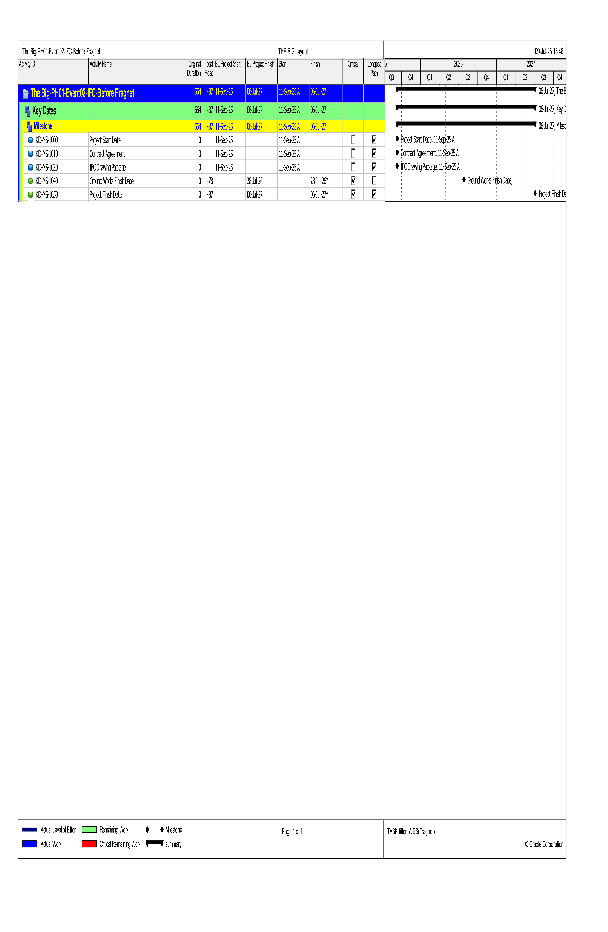
Activity Relationships & Fragnets Network

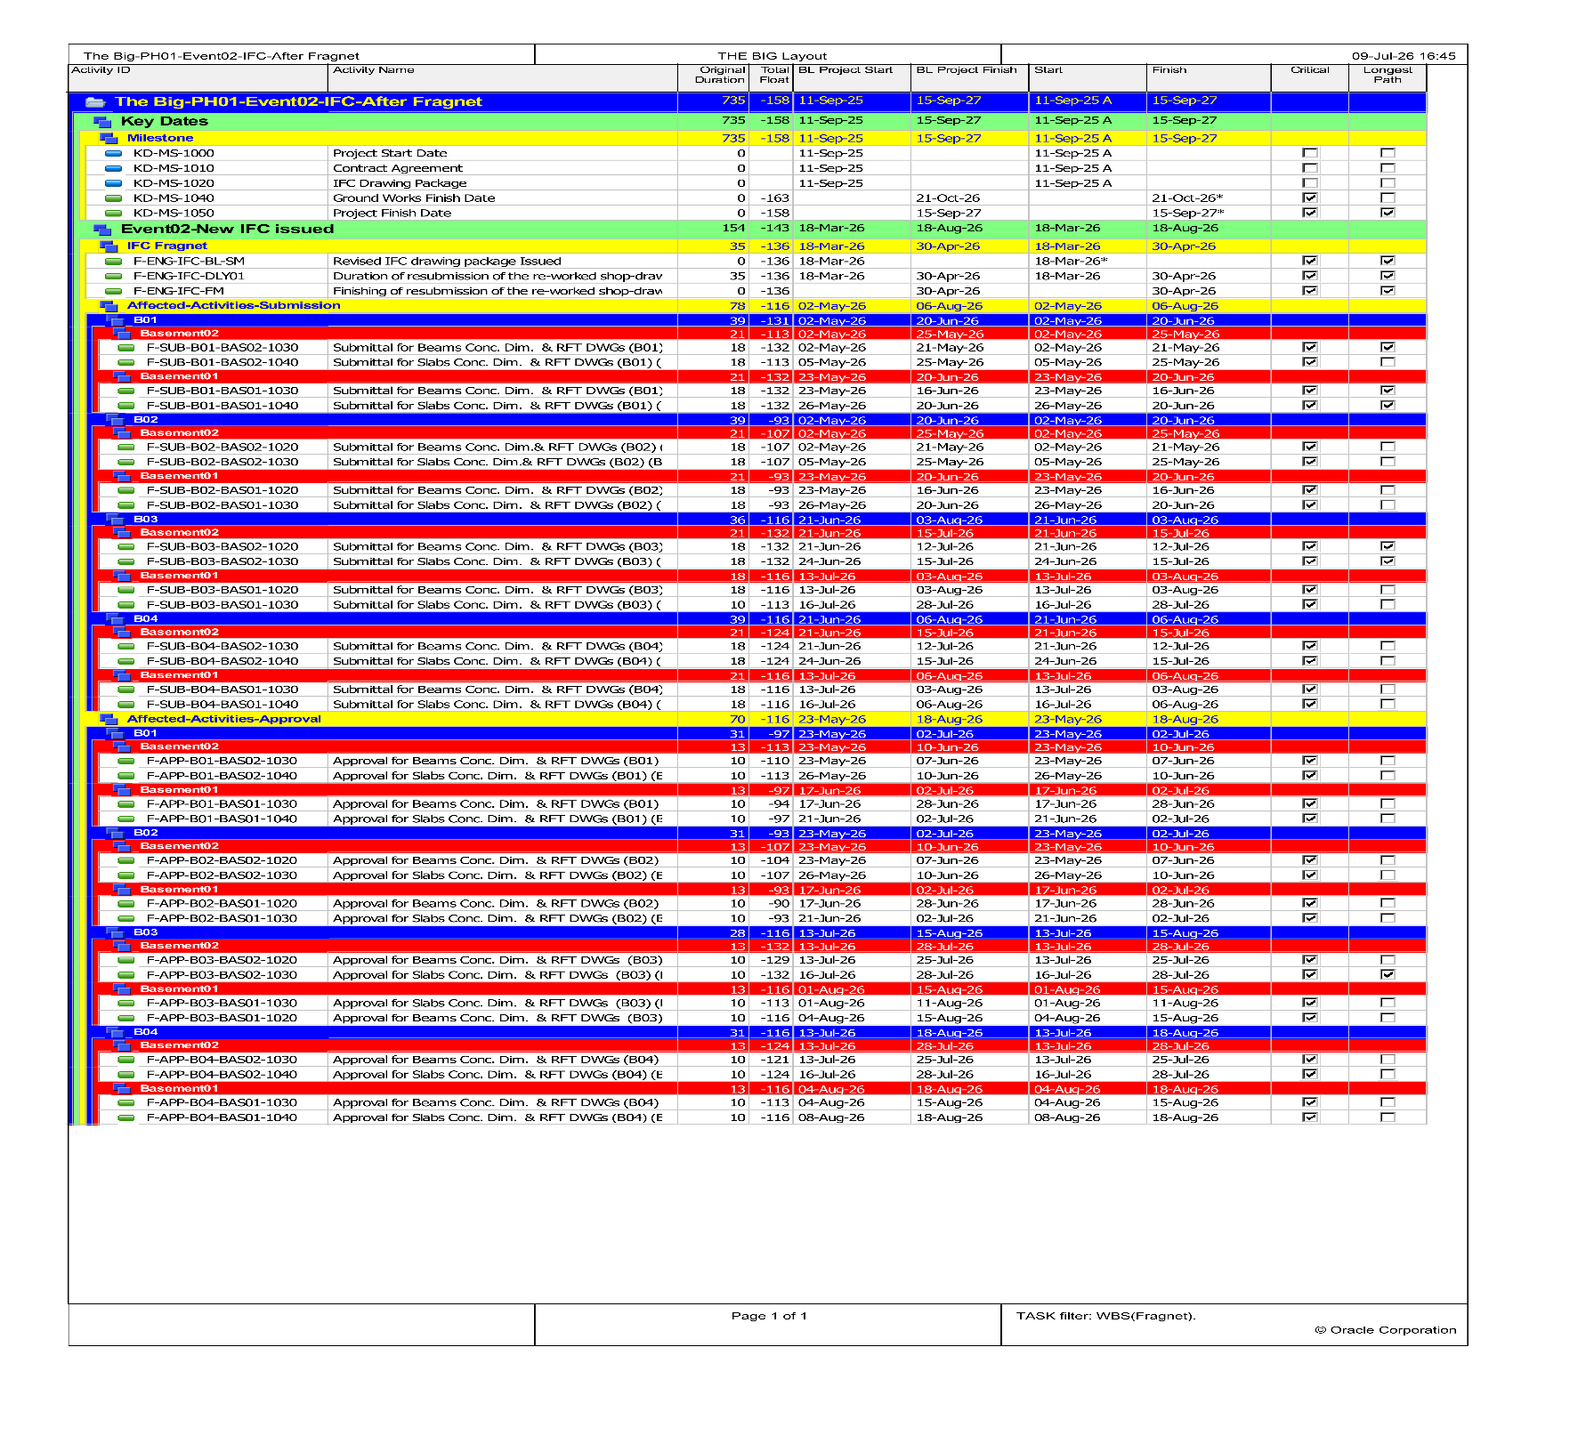
`(EV02-IFC-Before Fragnet Activities)

(EV02-IFC-After Fragnet Activities)

Contractual milestones and completion assessment
Delay Event | Data Date | Activity ID | Milestone / Activity Name | BEFORE FRAGNET |  | AFTER FRAGNET |  | Float Change  (Days) | Finish Movement
 |  |  |  | Total Float | Forecast Finish | Total Float | Forecast Finish
EV02 – IFC | 17-Mar-26 | KD-MS-1040 | Ground Works Finish Date | -78 | 28-Jul-26 | -163 | 21-Oct-26 | -85 | 85
EV02 – IFC | 17-Mar-26 | KD-MS-1050 | Project Finish Date | -87 | 6-Jul-27 | -158 | 15-Sep-27 | -71 | 71

Event No. (03): First Fix MEP Works

4.1 Executive Summary
The Contractor considers the activities of implementing such Works are a Variation Order, accordingly, the Contractor claims Extension of Time of this scope

4.2 Contractual Basis
Sub-Clause 13.3 [Variation Procedure] of the Conditions of the Contract

4.3 Factual Background
After numerous correspondences and negotiations between the Parties, the Contractor agrees to implement the first fix MEP Works. However, these Works are subject to a Variation Order, under which the Contractor is entitled to an Extension of Time and additional payments.

4.4 Entitlement
Accordingly, by virtue of this Claim, the Contractor hereby claims its entitlement to an Extension of Time for Completion for the period of delayed payments, pursuant to Sub-Clause 13.3 and Sub-Clause 8.4 of the Conditions of Contract, for 0 days

4.5 MEP Delay Analysis

CRITICAL NOTICE AND CORRESPONDENCE REGISTER
Date | Ref. | Event | Subject | Purpose | Relevant Provision
07-Oct-2025 | STR-016 | EV03 | Contract position / reservation | MEP scope boundary position | Contract scope; SC 4.4; SC 4.6; SC 13.1/13.3; SC 20.1
24-Nov-2025 | STR-024 | EV03 | Variation rejection | Reservation that instructed MEP works are outside civil scope | SC 4.4; SC 4.6; SC 13.1/13.3; SC 20.1
06-Jan-2026 | STR-041 | EV03 | Urgent notice / conditional proposal | Critical sewage interface and mitigation proposal | SC 4.6; SC 13.1/13.3; SC 8.4; SC 20.1
29-Jan-2026 | STR-049 | EV03 | Response / conditional acceptance | Conditional acceptance subject to variation procedure | SC 13.3; SC 8.4; SC 20.1

EV03 - Engineer-Instructed Additional MEP Embedded Works
INSTRUCTION  Additional / instructed embedded pipes, sleeves, puddle flanges and conduits. | ADDED PROCESS  Engineering submittal, approval, procurement, fabrication and installation. | CIVIL INTERFACE  Embedded items required before associated raft / wall concrete works. | CURRENT TIA RESULT  No movement of Project Finish in the before / after comparison presently available.

The current EV03 before / after comparison shows no movement in the Ground Works Finish or Project Finish milestones. Accordingly, the present schedule output does not demonstrate an EOT quantum for EV03. This does not determine or waive the Contractor's separate variation, valuation, disruption or cost entitlement, nor does it prevent a later time assessment if the event's actual impact changes or further evidence demonstrates critical delay

Table 1: MEP Schedule
Activities — Water Tank MEP First Fix
Activity ID | Activity Name | MEP Duration
Engineering
Submission
WT-Plmb-ENG-Pips | Submission of embedded pipes, washout/drain Shop-drawings | 18
WT-Plmb-ENG-SL | Submission of sleeves, puddle flanges Shop-drawings | 18
WT-ELEC-ENG | Submission of conduits and sleeves for level sensors and control cables Shop-drawings | 18
Approval
APP-WT-Plmb-ENG-Pips | Approval of embedded pipes, washout/drain Shop-drawings | 10
APP-WT-Plmb-ENG-SL | Approval of sleeves, puddle flanges Shop-drawings | 10
APP-WT-ELEC-ENG | Approval of conduits and sleeves for level sensors and control cables Shop-drawings | 10
Procurement
PRO-MEP | Fabrication & Supply of Material | 4
Construction
CON-WT-PLMB-RFT | Installation of embedded pipes, washout/drain | 5
CON-WT-PLMB-Walls | Installation of sleeves, puddle flanges | 4
CON-WT-ELEC-Walls | Installation of conduits and sleeves for level sensors and control cables | 4

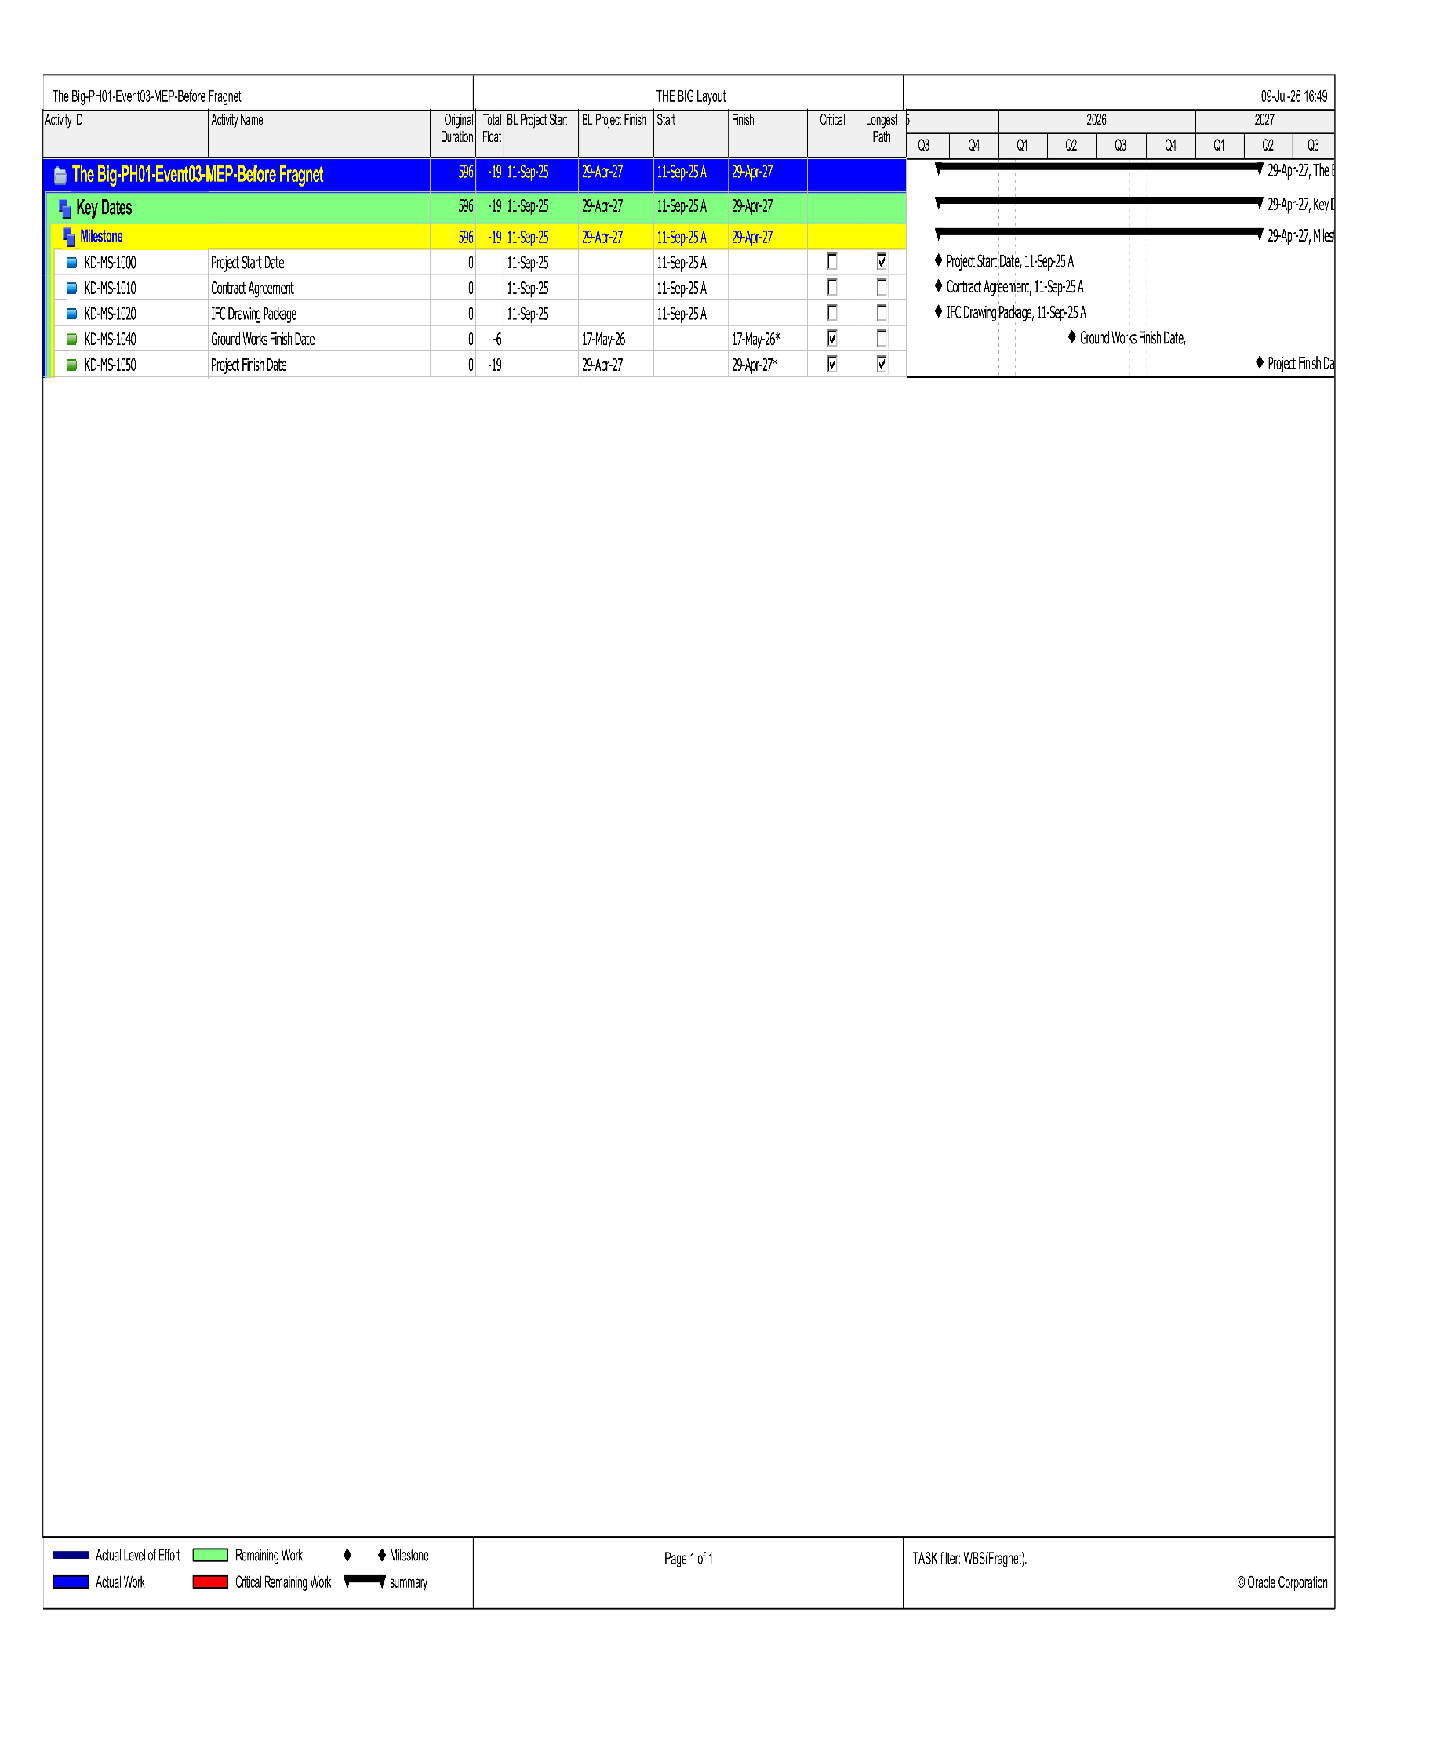
Activity Relationships & Fragnets Network

(EV03-MEP-Before Fragnet Activities)
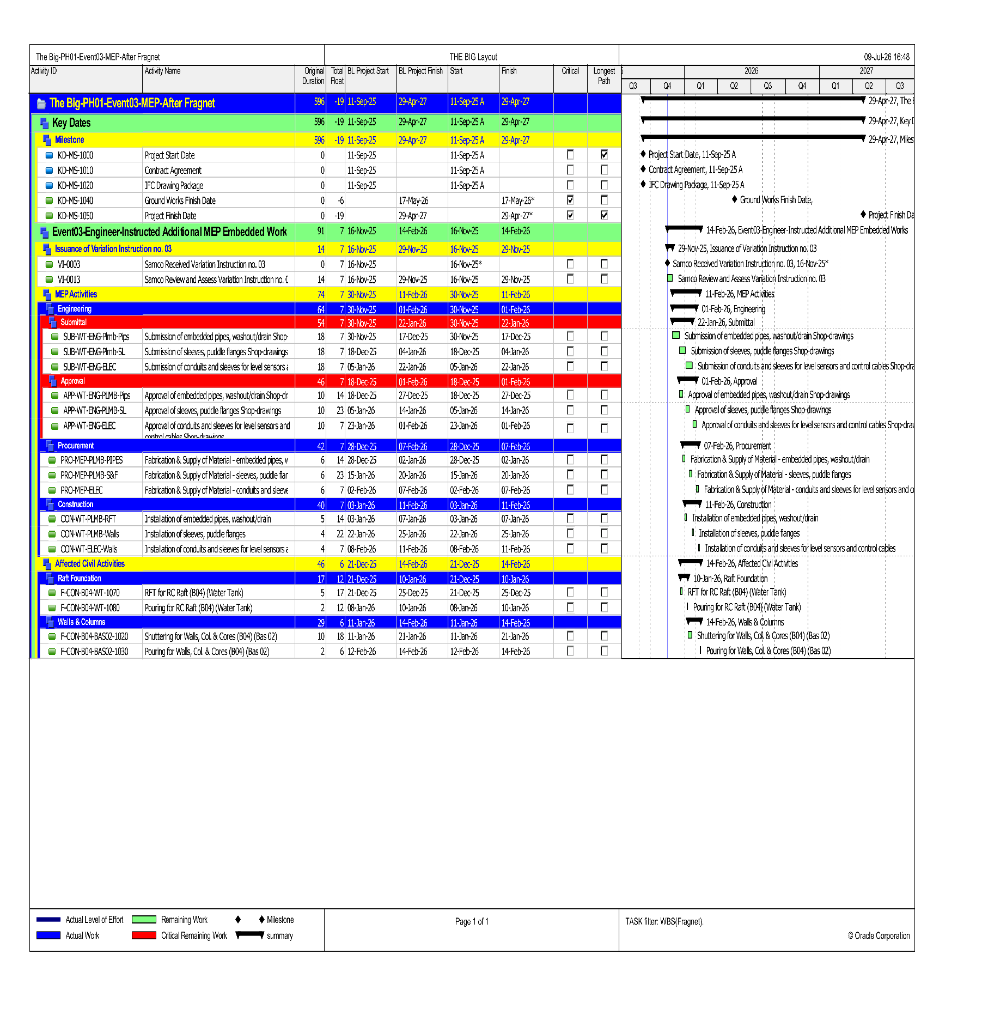

(EV03-MEP-After Fragnet Activities)

Contractual milestones and completion assessment

6.Consolidated Summary of Entitlements
The following table summarizes the Contractor's consolidated claim for Extension of Time:
Claim No. | Description | EOT Claimed (Days)
01 | Delayed Supply of Free-Issue Steel Reinforcement by the Employer | 106
02 | Change in Issued for Construction (IFC) Drawing Packages | 37
03 | Water Leakage in Project Site | 12
04 | Engineer's Delayed Reply to the Contractor's Documents | 13
# | Total Extension of Time Claimed | 131
# | Original Completion Date | 11 April 2027
# | Revised Completion Date (after EOT) | 19 August 2027

7.Caveat
This is a claim submission for the purpose of providing a supported case for the Contractor’s entitlement to extension of Time for Completion and the associated cost as a result of the events detailed in this submission. The Contractor reserves its rights to amend, supplement, omit, or provide further information at any time should this be considered appropriate by either Party.
Neither the adopted methodology nor the claim generally takes into account any events taking place for reasons other than the subject matter of the claim or for events occurring during the period of time not considered under the claim. Contractor reserves all rights to pursue such matters separately.

Samco Al-Wataniya
for Construction
7b El Tayaran Street, Maniegel Al Cinema,
Nasr City, Cairo Governorate 4450106, Egypt
Contract Reference: Roya-Big-2025-01
This document is submitted without prejudice to the Contractor's rights under the Contract.
© 2026 Samco Al-Wataniya for Construction. All Rights Reserved.


